**Functional requirements:**

1. As an employee, I want to be able to register a pet in the system, including information about the pet’s name, age, gender, species, color, so I can easily search for the pet in the system.  
   Additionally, I want to be able to add comments about the pet:
   1. For dogs and cats, their breed and breeder information
   2. For rodents, behavior (if they bite)
   3. For fish, whether they live in salt water or fresh water. Whether they are predators or prey.
   4. For birds, special dietary needs.
   5. For all, comment like “under observation” (for health issues or behavior), so all staff are aware of which animals need special attention.
2. As an employee, when registering a pet for sale, I want to be able to add a price for it, so it is easily recognizable whether it is a pet shop pet or an animal currently staying in the kennel.
3. As an employee, I want to be able to change the price, in case I want to offer a discount to the customer.
4. As an employee, I want to have a system that separates the pets in the pet shop from the pets in the kennel, so we avoid another chihuahua catastrophe.
5. As an employee, I want to be able to remove/delete a booking from the system in case the customer wishes to cancel.
6. As an employee, I want to be able to modify an existing reservation in case the customer wishes to change the date or time.
7. As an employee, I want to be able to input the date in the system to check the availability of rooms in the kennel during that period.
8. As an employee, if there are any available rooms, I want to be able to add a new booking to the system, so the availability will be updated.
9. As an employee, I want to be able to add a reservation only if there is open availability.
10. As an employee, I want to only be able to register a maximum of ten bookings simultaneously, so we ensure that there is open availability.
11. As an employee, I want to only be able to change an existing reservation to another date, if there is open availability on the day the customer wishes to change to.
12. As an employee, I want to have a record of each pet’s previous owners, if applicable, so I can reference this information if necessary.
13. As an employee, I want to be able to modify existing information about the pet in case the pet gets a new owner.
14. As an employee, I want to be able to remove/delete a pet from the system in case the pet passes away.
15. As an employee, I want to be able to register a new customer in the system by registering the customer’s name, email address and phone number and/or birthday and/or a home address, so I can easily search for them in the system and contact them, if necessary.
16. As an employee, I want to be able to modify an existing customer’s information, in case they change their name, email address and/or phone number.
17. As an employee, I want to be able to remove/delete a customer’s information from the system in case they do not wish for the shop to store their information anymore.
18. As an employee, I want to be able to link a pet registered in the system to a customer, newly registered or already registered in the system, so I can keep track on who the owner of the pet I have sold is.
19. As an employee, I want to be able to add new pets to the pet shop list of pets (adding a new pet for recycling).
20. As an employee, I want to be able to display information a website including photos, information about pets for sale and room availability, so the customer can see what we offer.
21. As a customer I want to be able to see the availability of the rooms in the kennel through a website so I can easily know if there is room for my pet in the desired period.
22. As a customer I want to be able to view a list of all available pets with their prices, so I can decide which one I’d like to buy.

**Non-functional requirements:**

1. As an employee, I want to be able to store the data in files, and not in a database system.
2. As an employee, I want the website to update the information automatically, as I update the application.
3. Every update in the system includes writing to a file.

**Use case diagram:**

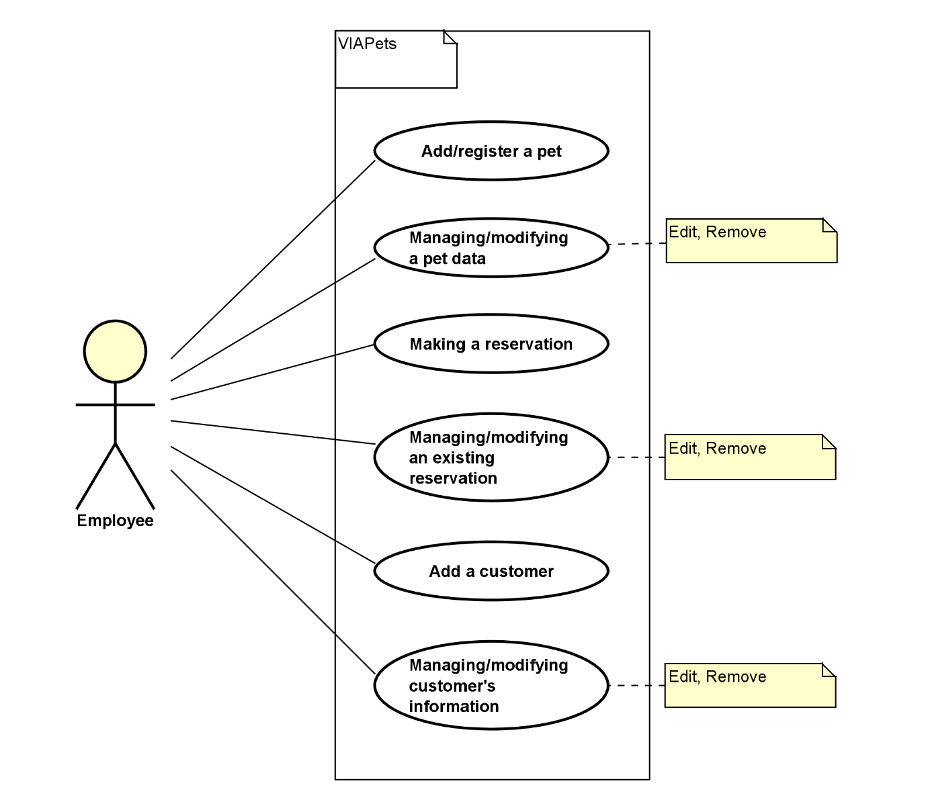

**Use case description:**

**Use case descriptions**

|  |  |
| --- | --- |
| **Use case 3** | **Making a reservation** |
| **Summary** | Create a new kennel reservation for a customer's pet |
| **Actor** | Employee |
| **Precondition** | * System is operational * Space is available in the kennel (max 10 pets) * Customer and pet data exists in system |
| **Postcondition** | * New reservation is created and stored in system files * Kennel availability is updated * Website availability information is automatically updated * All validation rules are satisfied |
| **Base sequence** | 1. System shows current kennel availability.  2. Employee enters desired reservation period [ALT1]  3. System displays availability for specified period [ALT2]  4. Employee searches for customer [ALT3]  5. System displays customer's registered pets [ALT4]  6. Employee selects pet for boarding [ALT5]  7. System validates the booking:   * Pet registration status * Existing reservations   8. Employee confirms booking details  9. System creates reservation and stores in files [ALT6]  10. System generates confirmation and updates availability display   |  |  | | --- | --- | | **Scenario A.**  **NEW CUSTOMER** | A.1. Employee selects "Register New Customer"  A.2. Employee enters customer details:  Name, Email, Phone number  A.3. System validates contact information  A.4. System saves customer data  A.5. Return to base sequence step 5 |  |  |  | | --- | --- | | **Scenario B.**  **NEW PET** | B.1. Employee selects "Register New Pet"  B.2. Employee enters pet details following registration requirements  B.3. System validates pet data  B.4. System links pet to customer  B.5. Return to base sequence step 6 | |
| **Alternative sequence (branch for exception)** | - [*ALT0]: Process can be cancelled at any step. Use case ends.  [ALT1]: If dates invalid:  1. System shows error message  2. System highlights valid date range  3. Return to step  [ALT2]: If no space available:  1. System shows next available dates  2. Employee can choose alternate dates or end use case  [ALT3]: Customer search options:  1. Search by name  2. Search by phone  3. Search by email  4. If not found, go to Scenario A  [ALT4]: If customer has no registered pets:  1. System shows warning  2. Option to go to Scenario B  [ALT5]: System validates pet status:  1. Checks if pet is already booked  2. Checks for health flags/special needs  [ALT6]: File storage validation:  1. Verify write success  2. Create backup  3. Update website data |
| **Note** | Covers requirements 7, 8, 9, 10, 15, 18 |

|  |  |
| --- | --- |
| **Use case 4** | **Managing an existing reservation** |
| **Summary** | Modify, cancel, or update an existing kennel reservation |
| **Actor** | Employee |
| **Precondition** | Reservation exists in system  Reservation data stored in files  Customer and pet data available |
| **Postcondition** | Reservation updated in system files  Kennel availability reflects changes  Website automatically updated  All modification rules satisfied |
| **Base sequence** | 1. System displays reservation list with filtering options:  By date range  By customer name  By status [ALT1]  2. Employee selects reservation [ALT2]  3. System shows detailed reservation information:  Booking dates  Customer details  Pet information  Special requirements  Current status  4. Employee selects action type:  IF MODIFY DATES then go to Scenario A  IF MODIFY DETAILS then go to Scenario B  IF CANCEL then go to Scenario C  IF ADD NOTES then go to Scenario D   |  |  | | --- | --- | | Scenario A.  MODIFY DATES | A.1. Employee enters new desired dates  A.2. System checks availability [ALT3]  A.3. System validates against booking limits  A.4. System updates reservation dates  A.5. System updates information |  |  |  | | --- | --- | | Scenario B.  MODIFY DETAILS | B.1. Employee selects information to modify:  Customer contact details  Pet information  Special requirements  B.2. Employee enters new information  B.3. System validates changes  B.4. System updates reservation  B.5. System updates information |  |  |  | | --- | --- | | Scenario C. CANCEL | C.1. Employee confirms cancellation [ALT4]  C.2. System checks cancellation policy  C.3. System updates reservation status  C.4. System frees up kennel space  C.5. System updates information and website |  |  |  | | --- | --- | | Scenario D. ADD NOTES | D.1. Employee enters new note/observation  D.2. System adds comments to the pet  D.3. System updates the information | |
| **Alternative sequence** | [*ALT0]: Process can be cancelled at any step  [ALT1]: Filtering options:  1. By date range  2. By customer name/phone  3. By pet name  4. By status  [ALT2]: If reservation not found:  1. System offers additional search options  2. Option to view cancelled reservations  3. Option to end use case  [ALT3]: If new dates are unavailable:  1. System shows next available dates  2. Option to waitlist  3. Option to keep current dates  [ALT4]: Cancellation validation:  1. Check notice period  2. Verify employee authorization  3. Option to add cancellation reason  [ALT5]: File system operations:  1. Verify write success  2. Update information. |
| **Note** | Covers requirements 5, 6, 11, 16 and non-functional requirements 1, 2 |

|  |  |
| --- | --- |
| **Use case 5** | Add cutsomer |
| **Summary** | Add a new customer record |
| **Actor** | Employee |
| **Precondition** |  |
| **Postcondition** | A new customer has been added to the system (and file) |
| **Base sequence** | 1. Enter values of the customer’s name, email address (in this format: [user@host.domain](mailto:user@host.domain)) and unique phone number 2. System validates data. [ALT3, ALT4] 3. System adds a new customer with the given data to the list and a file. 4. System shows a success message. |
| **Alternate sequence (branch or exception)** | [*ALT0]: The process can be canceled at all steps, ending the use case.  [ALT3]: If name is not a string with at least 2 characters representing first name, a space and at least 2 characters representing last name or if the Phone number is not a number, or birthday doesn’t represent a legal day, month and year, then System shows a message that data is invalid. Go to step 1.  [ALT4]: If Phone number is identical to the Phone number for another customer in the customer list, then System show a message that phone already exist. Go to step 1. |
| **Note** | A Customer record can be created only with Name and Phone number, but optionally also with Email and Address. This use case covers requirements:   * Functional(15) * Non-Functional(3) |

|  |  |
| --- | --- |
| **Use case 6** | Manage an existing Customer’s data |
| **Summary** | Show, Edit or remove a customer record. |
| **Actor** | Employee |
| **Precondition** | System cannot manage data if data is not registerd in the system. |
| **Postcondition** | Data for an existing customer has been shown or updated or an existing customer has been removed from the list. Updates are both in system and file. |
| **Base sequence** | 1. System show a list of all Customers, each element with at least Name, Phone number and Email. [ALT1] 2. Select a customer 3. System show customer data 4. Name 5. Phone number 6. Email 7. Address {Town, Street, Number, Letter, Floor, Door} 8. Birthday {Day, Month, Year} 9. IF SHOW then end the use case   IF EDIT then go to Scenario A. EDIT (step A.1),  IF REMOVE then go to Scenario B. REMOVE (step B.1)   |  |  | | --- | --- | | **Scenario A. Edit** | A.1. Enter/edit values for one or more of the data shown in step 3 A.2 Approve the updated data A.3 System validates data [ALT2, ALT3, ALT4, ALT5, ALT6, ALT7, ALT8] A.3. System show the customer data (as in step 3) and update system and file | | **Scenario B. Remove** | B.1. Verify removing B.2. The system removes the customer from the list [ALT9] B.3. System shows that the customer has been removed and updates system and file |   Use case ends. |
| **Alternate sequence (branch or exception)** | [*ALT0]: The process can be canceled at all steps, ending the use case. [ALT1] Enter part of the customer’s name or phone number and System show a list of the customers with the input as part of their name or phone number.  [ALT2] If name is not a string with at least 2 characters representing first name, a space and at least 2 characters representing last name or if the Phone number is not a number, then System show a message that data is invalid. Go to step A.1.  [ALT3] If Phone number is identical to the Phone number for another customer in the customer list, then System show a message that phone already exist. Go to step A.1.  [ALT4] IF customer’s Email is not empty or in the format “user@host.domain”, then system show a message about wrong email format. Go to step A.1  [ALT5] IF customer’s Address is not empty or in the format {Town, Street, Number, Letter, Floor, Door}, with Number being a number, Letter being empty or a character, and the remaining being strings, then system show a message about wrong format in address. Go to step A.1  [ALT6] IF Birthday do not represent a legal day with day, month and year, then system show a message about wrong date format. Go to step A.1  [ALT9] IF the customer attempted to remove has any reservations(if any reservations for this customer has status “Waiting” or Started”), then system show a message stating that a customer with reservations cannot be removed, and End the use case. |
| **Note** | A customer cannot be removed if he/she is part of one or more reservations in the reservation list. Instead, these reservations have to be ended or removed first.  This use case covers requirements:   * Functional(16, 17) * Non-Functional(3) |

**Link table between requirements and use cases**

|  |  |
| --- | --- |
| **Requirements** | **Use cases** |
| 4,5,6 | Pet shop management |
| 7,8 | Customer management |
| 1,2,3, 6 | Kennel management booking |

|  |  |
| --- | --- |
| Use case | Add/register pet |
| Summary | Add pet to the Pet Shop or kennel |
| Actor | Employee |
| Precondition |  |
| Postcondition | A Pet has been added to pet shop |
| Base sequence | 1. Enter which business Pet shop or kennel, pet name, different kinds of pets, age, gender and colour and if pet is preowned “recycled” or not. further information based on species of the pet.   For dogs and cats, their breed and breeder information   For rodents, behavior (if they bite)   For fish, whether they live in salt water or fresh water. Whether they are predators or prey.   For birds, special dietary needs.   For all, comment like “under observation” (for health issues or behavior), so all staff are aware of which animals need special attention.  Price if it is pets shop and no price for kennel. ALT1, ALT2,ALT3   1. Check if information is valid based on pet information if not repeat base sequence 1 ALT4 2. When everything is checked out add pets to the shop if they have a price and to the kennel if they don’t. ALT 5 ALT8 3. Check for duplication in information [alt6] 4. System approves the action if everything is valid and send a notification [alt9] [alt 7] |
| Alternate  sequence | [ALT0] In step 1, the process can be cancelled ending the use case.  [ALT1] Enter which business is the pet belongs to (pet shop or business), name, age, colour, recycled or not.  [ALT2] enter species of the pet, and more information based on species.  [ALT3] enter comment of the pet.  [ALT4] check if all information is correctly set and if not send message “Something is wrong with pet try from beginning” start from [ALT0]  [ALT5] check if it’s pet shop or kennel and separate based on value of which business and price (if price is 0 add to kennel).  [ALT6] if pet has the exact same information as in pet shop list  then System shows a message that pet already exist in pet shop. Go to step 1.  [ALT7] Add pet based on value of which value Business and price.  [ALT8] double check if system is separated based on business and price value and if not  System shows a message  that data is not in right path. Go back to step 1.  ALT 9 if everything is correct send a massage the pet is registered successfully. |
| Note | This cover requirements 1,2,3,4,6,14 |

|  |  |
| --- | --- |
| Use case | Managing/Modifying Pet Data |
| Summary | Describe how employee at VIAPets can change details of a pet in the pet shop or remove the pet from pet shop when it is sold or if pet is no longer available(dead) |
| Actor | Employee |
| Precondition | The pet is already in the petshop |
| Postcondition | The information about a pet is modified or deleted after a sale or if went to the other side(dead) |
| Base sequence | 1. Employee can login to system and find the pet information that needs to change or remove. (ALT1)   Employee selects action type:  IF MODIFY Pet then go to Scenario A  IF remove pet Sells pet then go to Scenario B  IF remove the pet except sale then go to Scenario C   |  |  | | --- | --- | | Scenario A | 1. The changes of the pet, the employee selects the pet info, changes the fields (e.g., change the price, change age, or if it still in the pet shop), and saves the changes. (ALT2) 2. System validates the new information and updates the pet’s record. (ALT3) 3. Send a message for confirmation of the action. | | Scenario B | 1. Pet get removed from pet shop if the pet is sold, employee marks the pet as sold, then he enters sales information like (sale date, customer info). (ALT4) 2. System validates the new information and updates the pet’s record. (ALT3) 3. System removes the pet from the available inventory list and logs the sale record. 4. System validates the new information and updates the pet’s record. (ALT3) 5. Send a message for confirmation of the action. | | Scenario C | 1. Removes the pet 2. System validates the new information and updates the pet’s record. (ALT3) 3. Send a message for confirmation of the action. |  1. System validates the new information and updates the pet’s record. (ALT3) 2. Send a message for confirmation of the action. |
| Alternate  sequence (ALT) | 1. If system couldn’t find the pet because for upper or lower case letter force all pet first name letter to be upper case letter. and then try again 2. If system couldn’t modify because the information isn’t same type as required send message that I numbers can’t stored as letters. Please try again 3. If there is an error let the employ try again 4. If removing pet is not count as sold then ignore sale date, customer information and final price and send a message the pet is not sold (probably dead) |
| Note | This cover requirement 5,7,15,16, |